Campaign Management

SQL Setup

Prepare your SQL Server 2016 Installation

Complete the steps in the Set up SQL Server R Services (In-Database) Instructions. The set up instructions file can found at the <https://msdn.microsoft.com/en-us/library/mt696069.aspx>

# Set up logins in SQL Server

* 1. In SSMS, connect to the Server with your admin account
  2. Create a new user: Right click on Security and select New > Login  
     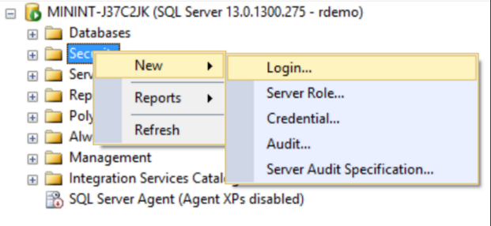
  3. Create a new Windows authentication user with the Login name “<machinename>\SQLRUserGroup”

To find your computer name. Open System by clicking the Start button, right-click Computer, and then click Properties. Under Computer name, domain, and workgroup settings, you can find your computer name and full computer name if your computer is on a domain.

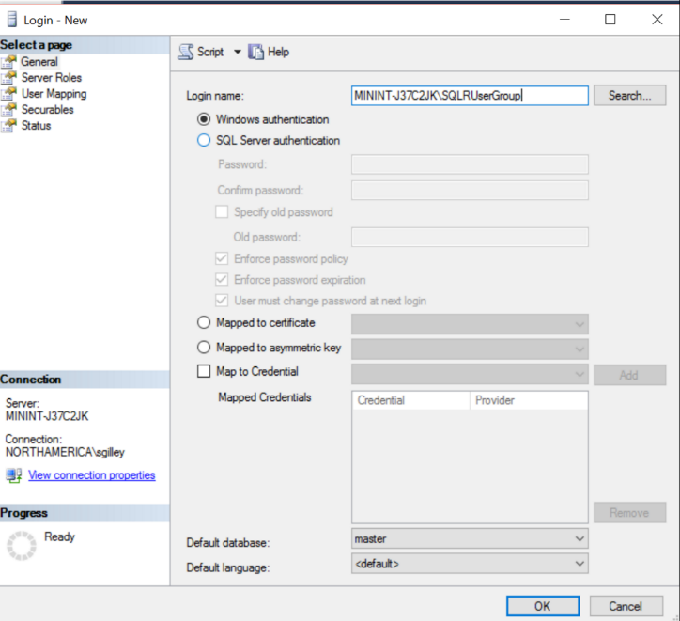

(It is mandatory to use the Trusted Connection method of accessing the database in an R connection string.)

* 1. Create the “rdemo” user by opening the **Resources/createuser.sql** file and executing it.

(This user login will be used to install data and procedures via the PowerShell script in a later step in this setup).

* 1. In the Object Explorer, select this new user and double click or right click and select Properties

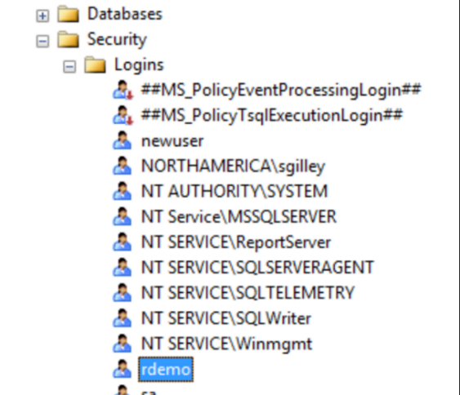

* 1. On the Server Roles tab check public and sysadmin.  
     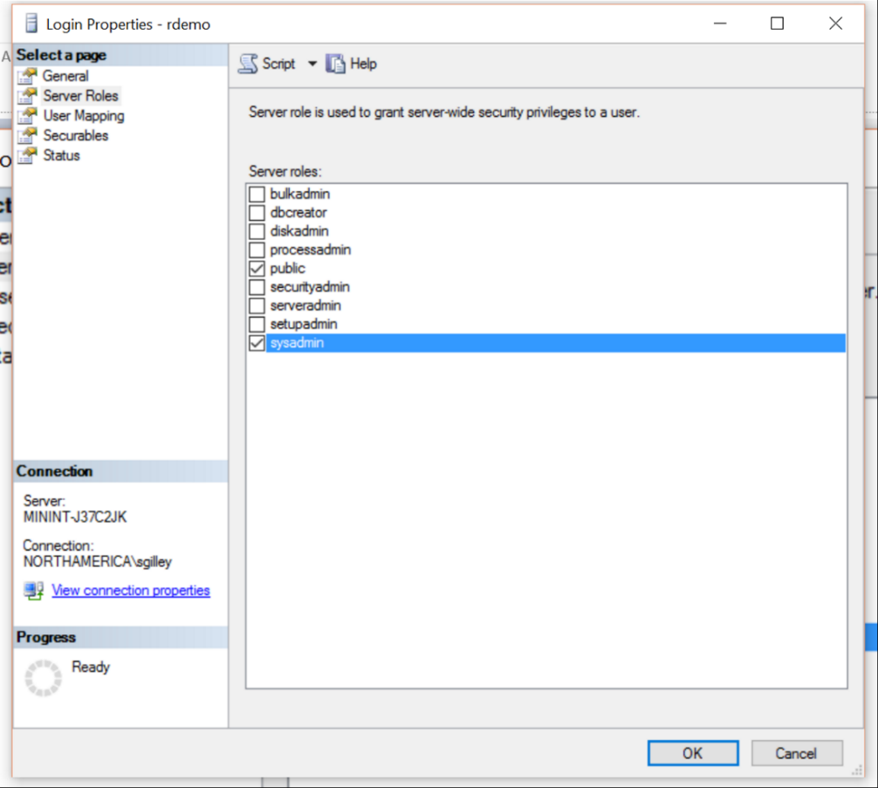
  2. On the User Mapping tab, check “master” in the top section, then check *db_datareader, db_datawriter, db_owner,* and *public* in the bottom table.  
     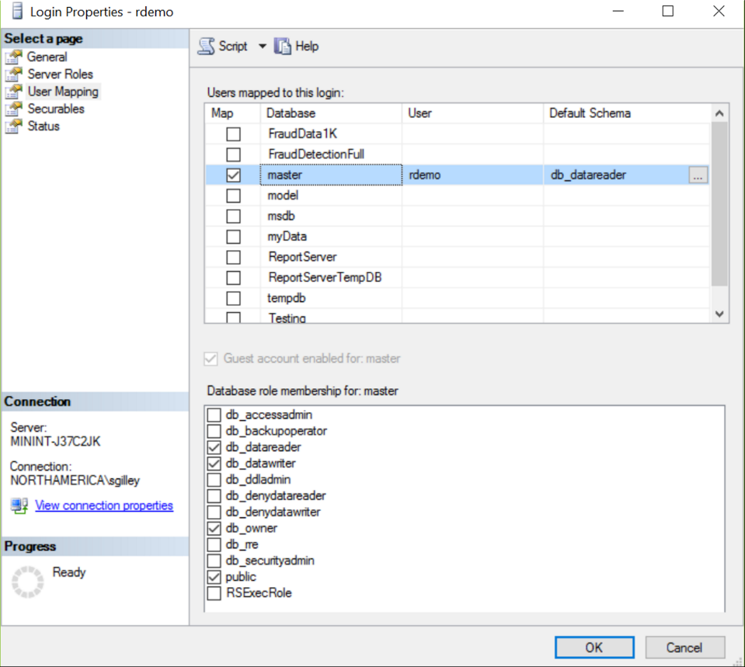
  3. Now, click on ‘File’ on the top left corner of the SQL Server window and select ‘Connect Object Explorer…’ verify that you can connect to the server with this username(rdemo) & password(D@tascience).  
     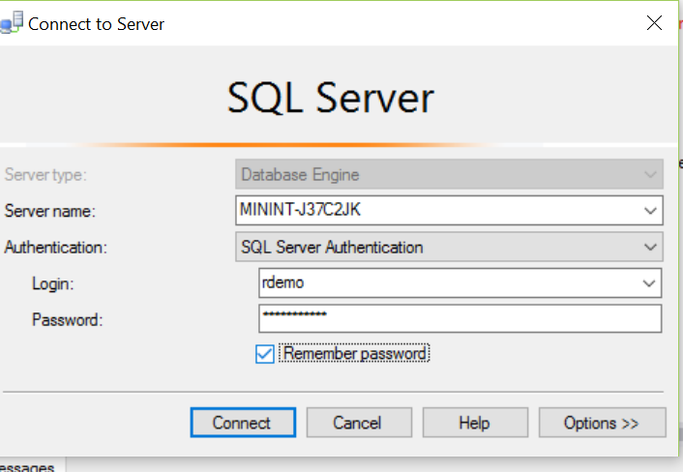

If you get an error here, check to make sure you have set your Server Authentication mode to **SQL Server and Windows Authentication mode.** See <https://msdn.microsoft.com/en-us/library/ms188670.aspx> for details.

# Install data.table Package on SQL

1. Install the data.table package into SQL R:
   1. On the machine with your server, open a command window as “Administrator” and submit the following commands:  
        
      cd "C:\Program Files\Microsoft SQL Server\MSSQL13.MSSQLSERVER\R_SERVICES\bin"  
      R
   2. Once you see the R prompt, execute the following commands:

install.packages("data.table")

install.packages("ROCR")  
q()  
n

# Create Database

1. In SSMS, create the “CampaignManagement” Database to be used for this solution.

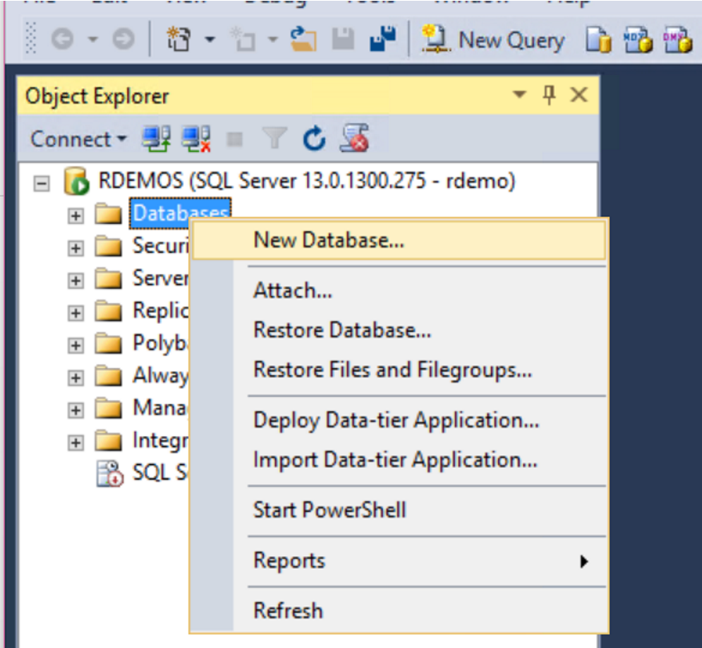

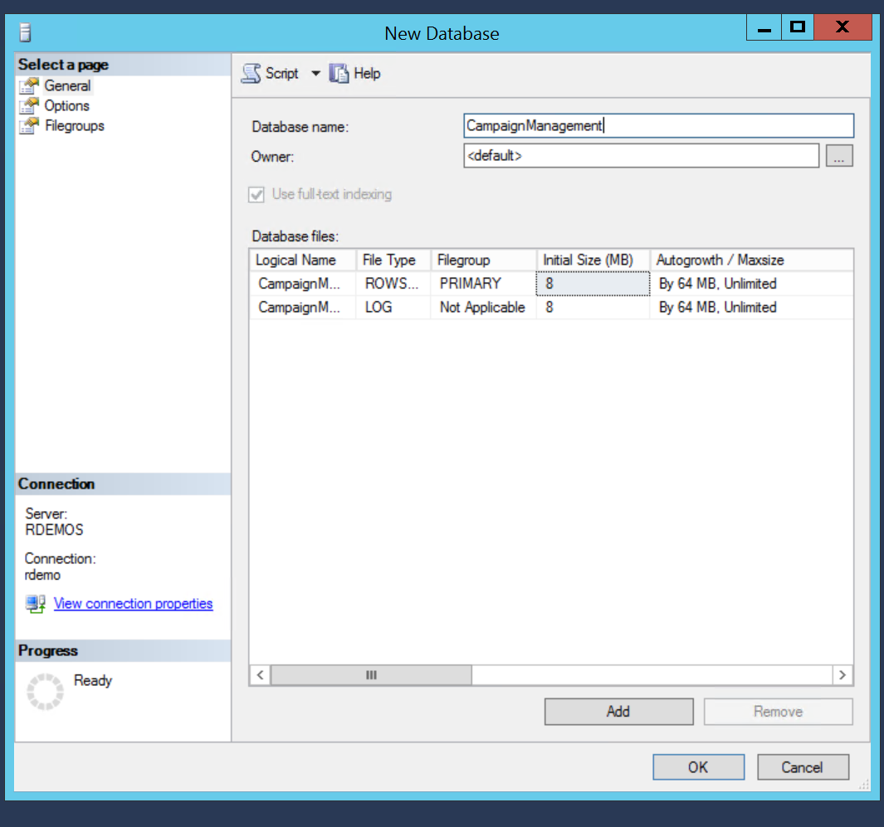

# Set up Connection between SQL Server and PowerBI

1. Push the Windows key on your keyboard
2. Type ODBC
3. Open the correct app depending on what type of computer you are using (64 bit or 32 bit). To find out if your computer is running 32-bit or 64-bit Windows, do the following:
   1. Open System by clicking the Start button, clicking Control Panel, clicking System and Maintenance, and then clicking System
   2. Under System, you can view the system type
4. Click on ‘Add’

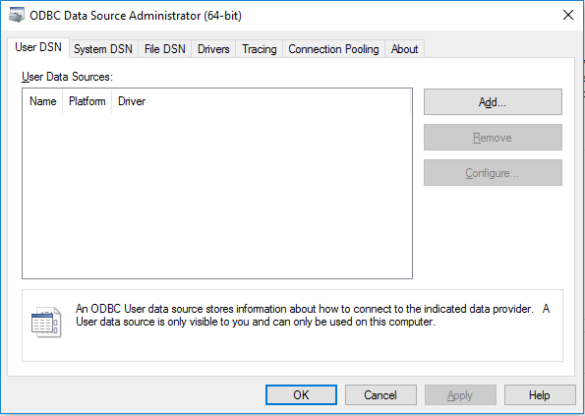

1. Select ‘Server Native Client 11.0’ and click finish

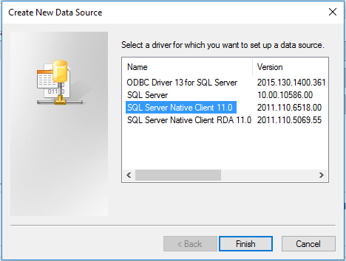

1. Under Name, Enter ‘CampaignManagement’. Under Server enter the MachineName from the SQL Server logins set up section. Press ‘Next’

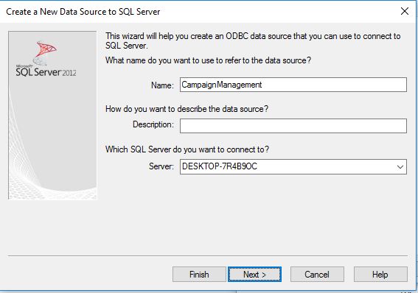

1. Select SQL Server authentication and enter the credentials you created in the SQL Server set up section. Press ‘Next’

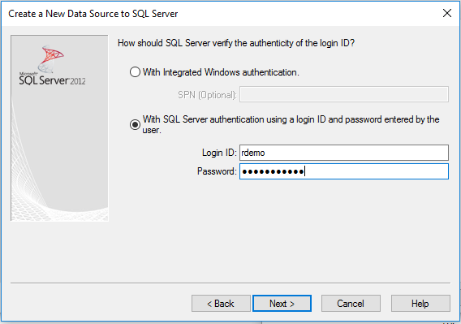

1. Check the box for ‘Change the default database to’ and enter ‘CampaignManagement’. Press ‘Next’

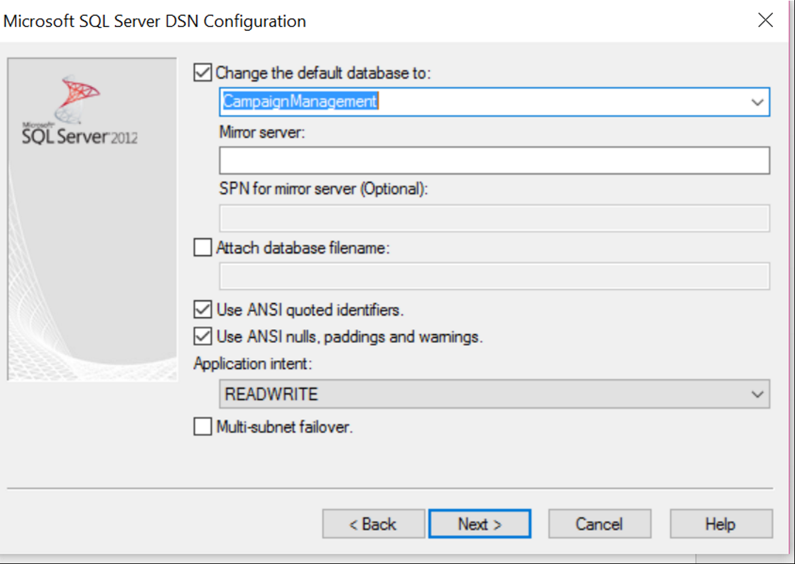

1. Press ‘Finish’

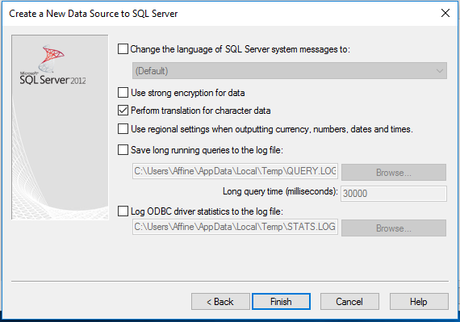

1. Press ‘Test Data Source’

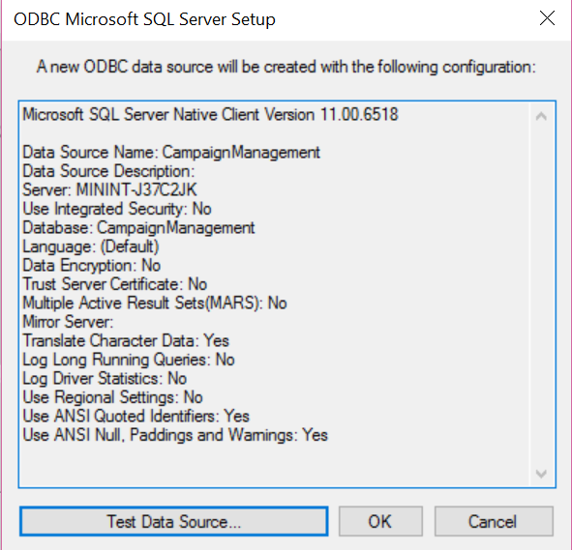

1. Press ‘OK’ in the new popover. This will close the popover and return to the previous popovers

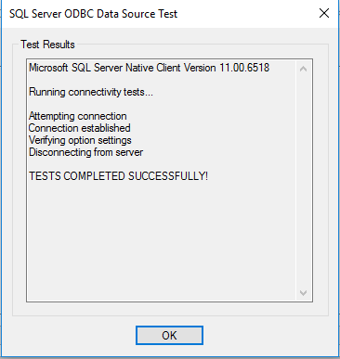

1. Now that the Data Source is tested. Press ‘OK’

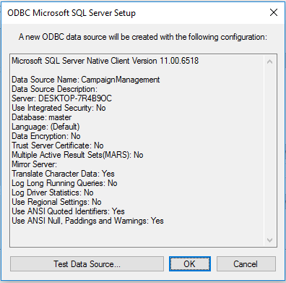

1. Finally, click ‘OK’ and close the window

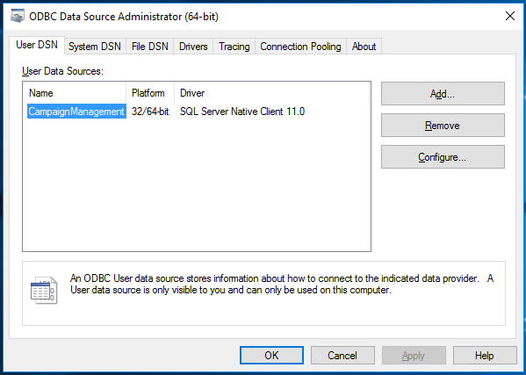

# Ready to Run Code

You are now ready to run the code for this solution. Find the instructions for running the fully automated solution in:

* [Automation with PowerShell](C:\\GitPrivate\\Azure-MachineLearning-DataScience-Private\\Misc\\SQL_RRE_Templates\\CampaignManagement\\Resources\\Instructions\\Powershell Instructions.docx)

You could also step through the parts of this solution with SQL files by using:

* [Model Development in SQL Server 2016 R Services](SQLR%20Instructions.docx)

Finally, you can step through the R code in your own R IDE by following the instructions in:

* Model Development in R